Feature Image: "Jewelry tips you need—read now!"

Title: 10 Tips for Shopping Affordable Fine Jewelry Without Sacrificing Quality
Primary Keyword:
Affordable Fine Jewelry
Related Keyword:
Luxury Albuquerque jewelry store
Custom Design Jewelry
Albuquerque Jewelers
CUSTOM DESIGN JEWELRY IN ALBUQUERQUE
Jewelry Store Albuquerque, NM

Internal Link:
best jewelry store in Albuquerque, NM: https://crownjewelsandcoin.com/

Word Count: 1200

Meta Title:
10 Tips for Shopping Affordable Fine Jewelry Without Sacrificing Quality | Crown Jewels & Coin
Meta Description:
Find out how to buy stunning, high-quality fine jewelry on a budget! Crown Jewels & Coin shares 10 expert tips to help you shop smart without compromising.

10 Tips for Shopping for Affordable Fine Jewelry Without Sacrificing Quality
At Crown Jewels & Coin, we believe that every single person should be able to own amazing fine jewellery that expresses their style without draining their bank account. It doesn’t matter if you’re searching for an engagement ring, a classic necklace, or your unique design; quality is not to be compromised. Here are 10 insider tips for you to get your hands on some affordable but dazzling, long-lasting fine jewelry, which is more like a luxury investment.

1. Know What “Affordable Fine Jewelry” Really Means
Affordable doesn’t mean cheap. At Crown Jewels & Coin, “affordable fine jewelry” means luxuriously fine jewelry made from the finest materials: 10K and 14K gold, as well as ethically-sourced gemstones and expert craftsmanship at a price everyone can afford. With the focus on value, the relative cost per wear and longevity of a piece are more important than its price. For instance, a simple 14K gold bracelet from our collection will be more affordable upfront than a hot new designer piece, but its timeless look will result in many years of wear. Ethical sourcing is also one of our top priorities, and we work with suppliers that follow fair labor practices, so you can feel good about what you’re buying.

2. Research Trusted Local Jewelers (Our Like)!
Avoid mass-market retailers and find local experts with whom to affiliate. We place a high value on transparency and quality, which makes us a leading Jewelry Store Albuquerque, NM. Local jewelers such as Albuquerque Jewellers always give competitive prices, personal service, and unique designs that aren’t available anywhere else. At Crown Jewels & Coin, our team spends some time to understand what you need whether shopping for an engagement ring or a gift. Even consultations are free to help you find options within your budget. Added benefits, supporting your community, keeping your dollars in your community… win-win!

3. Opt for Lab-Grown Diamonds
Artificial diamonds are identical to mined diamonds from a chemical standpoint, but are 30 to 50% cheaper. They’re environmentally friendly, problem-free, and ideal for engagement rings or statement earrings. We provide the most beautiful lab-grown products here at Crown Jewels & Coin, far beyond the brilliance of natural stones. For example, our lab-grown sapphires have the same rich blue color as already mined stones, but with less environmental cost. Pair them with recycled gold for a piece that’s both affordable and sustainable.

4. Prioritize Craftsmanship Over Brand Names
Price inflation occurs for logos from luxury brands, not for quality. Rather, try to find jewelers who favor craftsmanship. Our Albuquerque Custom Design Jewelry is made by experienced artisans, and every detail is gorgeous, no brand's markup needed. Take our signature solitaire rings. In these rings, both prongs are carefully crafted by jewelers who have served this role for many decades, so your stone is held firmly in place. We also provide lifetime warranties for all custom pieces, so you invest in peace of mind.

5. Explore Pre-Owned or Estate Jewelry
Unlike trendy, vintage is also cost-efficient. Many pre-owned items at our Luxury Albuquerque Jewelry Store use high-quality materials at a small fraction of the price. At Crown Jewels & Coin, part of our estate collection includes Art Deco and mid-century modern diamond rings and brooches, respectively, which are all professionally cleaned and inspected for authenticity. These pearls have history and character that you cannot reproduce, and have a story of eternal elegance.

6. Focus on Versatile, Timeless Designs
Trends fade; classics endure. Go for all-purpose items, such as a solitaire necklace, stud earrings, or bare belts. These staples complement any dress and retain their value with time. Review our assortment of Affordable Fine Jewelry for enduring style to include our “Everyday Hoops” in sterling silver that can be worn daily, yet made as befitting for special occasions, not heavy or worn down.
Pro tip: Introducing subtle layering via delicate chains or simple nest stacking of dainty rings will refresh your look without blowing your budget.

7. Make Your Jewelry a Personal Statement and Get More Out of It.
Why settle for generic? Our customer Design Jewelry allows you to order an individual piece for your specific budget. At Crown Jewels & Coin, we help you choose materials, stones, and designs that are in tune with your vision and your wallet. For instance, create a pendant by using a family heirloom diamond and a new setting in 14K gold. Our 3D design programming will help you to see the item before it is created, and top quality is guaranteed. Customization also means no unnecessary extras, you pay only for what you love.

8. Understand Available Metal Choices
Not all gold is equal. Choose 10K over 14K gold because it’s more durable and affordable, and whatever it lacks in color, it has made up for in amount. Platinum and sterling silver also make great, affordable fine jewelry. Consult our team at the number one jewelry store in Albuquerque, NM, for help! For example, platinum is hypoallergenic and is perfect for sensitive skin; vermeil (gold-plated sterling silver) can give you a luxe look without spending an arm and a leg. We will explain alloy percentages, maintenance tips, and caring for your metal to shine.

9. Check for Certifications & Guarantees
Never forget to check for diamonds and gemstones (GIA / AGS reports) verification. Respected jewelers, such as we, provide warranties and complimentary cleanings to ensure your investment is protected. From Crown Jewels & Coin, all the diamonds over 0.5 carats are accompanied by a GIA certificate, which includes how the stone was cut, color, clarity, and its 0.5 carats. We also offer complimentary yearly inspections to tighten prongs, polish metals, and keep your jewels in gem quality.

10. Time Your Purchase Strategically:
Shop on holiday sales, anniversary sales, or off-season. At Crown Jewels & Coin on Valentine’s Day, Black Friday, and Mother’s Day, we reward thrifty purchasers with unique deals in Affordable Fine Jewelry. Sign up for our newsletter and you’ll be among the first to get access to great offers, such as off custom designs on Mother's Day, or bonus loyalty points during December. Even better: Our layaway plan lets you hold pieces while you make the interest-free payments to purchase later without missing out.

Why Choose Crown Jewels & Coin?
We’re not just a jewelry store, we’re your partner to find beauty that fits your budget. Being a reputable Jewelry Store Albuquerque NM, we combine luxury and affordability because we have:
- Custom Design Jewelry in Albuquerque: Whether it is a vintage-inspired engagement ring or a geometric pendant, our design team makes your dream ring in reality. We make detailed previews of your piece, using 3D modeling software, before we craft it ourselves. Want to reuse an heirloom of your family? We’ll incorporate heirloom stones back into new, modern scenarios, combining tradition and innovation.
- Ethnocentrically Harvested Gemstones and Lab-Grown Diamonds: We work with suppliers who are certified by the Responsible Jewellery Council, and every stone is required to adhere to very strict ethical specifications. Lab-grown as our radiant 1-carat round cuts are, our lab-grown diamonds have the same fire and brilliance as mined diamonds, but a smaller footprint.
- Highly Skilled Craftsmanship: Our artisans have several decades of experience in making jewelry from hand-engraving complex patterns to stone setting with precision. Unlike big box retailers, we do away with middlemen, who pocket purchasing-cost savings directly for your benefit. Our handmade gold hoop earrings come at a special discount comparably branded luxury, but at the same value.
- Transparency and Educating Consumers: We simplify the process of jewelry shopping with free guidelines on diamond grading, how to take care of metal, and how to recognize value. Even our team will instruct you on how to inspect prongs or test gold purity, and hence equip you to shop with confidence.
Come to our showroom or see our Affordable Fine Jewelry online today. Whether for anniversary presents or regular life essentials, we assist you in capturing life’s moments through things that are as individual as you are; we never scrimp on quality.

Ready to Find Your Perfect Piece?
Come into Crown Jewels & Coin, the finest jewelry store in Albuquerque, NM, or request a personalized consultation to begin designing your dream jewelry. During your visit, enjoy:
- Free styling sessions: Our experts will help you mix and match items, such as layering a custom necklace design with our most popular bracelet charms.
- Exclusive previews: You will be the first to witness fresh arrivals, such as our New Mexico inspired limited edition turquoise rings.
- Stress-free financing: Make use of our interest payment plans, and Affordable Fine Jewelry just gets more affordable.
Can’t visit in person? Schedule a virtual consultation! We’ll work together in a video call, and let us curate a digital list of options to your taste and budget.
Don’t wait, Affordable Fine Jewelry that looks and feels luxurious is a click or a visit-away. Becoming a member of thousands of happy customers who’ve found their forever pieces at Crown Jewels & Coin. Your story has a right to shine. Let's write it together.
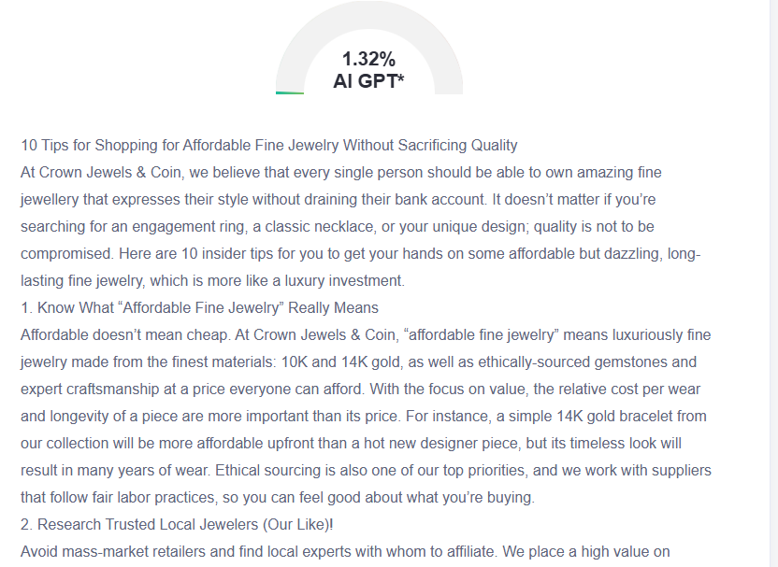

GMB
Crown Jewels & Coin helps everyone own fantastic, fine jewelry that suits people’s style and budget. We have 10K and 14K pieces of gold; ethically-sourced gemstones; expert-crafted skills, in price ranges that suit you. Our affordable fine jewelry offers value that outlasts and is wearable every day. We promote transparency and quality in the idea of being the best jewelry experts in Albuquerque. Our team spends time to understand what you need and offers free consultations to suit your budget. Our artisans will design pieces to order with careful regard to every detail and guaranteed by lifetime warranties. Our everlasting styles, including solitaire necklaces and stud earrings, fit every outfit and maintain value. Using 3D design technology, we design your personal jewellery, which conforms to your vision and price range. We lead you through metal options: 10K gold for strength, platinum for sensitive skin. We have special rates during holidays, and an interest-free layaway plan. Our custom design team makes your dream jewelry come to life using precise 3D previews. We use family heirloom stones in a contemporary setting. We obtain our resources from Responsible Jewellery Council-certified suppliers. Our skilled craftsmen deal with intricate engraving and delicate stone quarries. Request a private consultation via the virtual session to discover a tailored list of options that fit your taste and your budget.

